Remote Method Invocation (RMI)

The Java Remote Method Invocation (RMI) system allows an object running in one Java virtual machine to invoke methods on an object running in another Java virtual machine. RMI provides for remote communication between programs written in the Java programming language. RMI applications often comprise two separate programs, a server and a client. A typical server program creates some remote objects, makes references to these objects accessible, and waits for clients to invoke methods on these objects. A typical client program obtains a remote reference to one or more remote objects on a server and then invokes methods on them. RMI provides the mechanism by which the server and the client communicate and pass information back and forth. Such an application is sometimes referred to as a *distributed object application*.

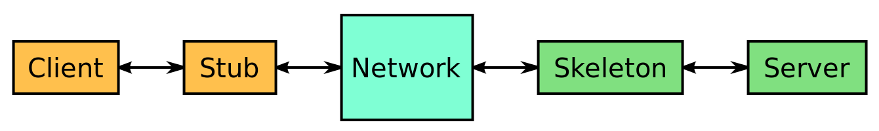

A typical implementation model of Java-RMI using stub and skeleton objects.

In this program, we are implementing the following properties:

1. **Go** – Client will enter x-axis and y-axis location which shift its current location of client terms of North, West, South and East locations.
2. **Get location** – This property user can get its location.
3. **List 30** – This will fetch all the clients which are within the range of 30m. After getting the information the client can select any of other client in the range of 30m and start the chat conversation.
4. **Send user-id msg** – The user can communicate with the other users and can send messages.
5. **Quit** –user can quit at any time and can leave the application.

In order to launch the application, we first need to create the server side, then we need to connect the server and client side. Once done, we will provide the rmiregistry. After this, we will establish a connection by using the rmic command for the server side. Similarly we will provide the connection for the client side using again the rmic command. After this, run the ServerMain and finally run the ClientMain.

Depending upon the number of clients required, open the ServerMain and establish the connection by providing the clients name, location and age. Make sure that there is a single space after every input. Example: Jinay 30 55 23. Now open another command prompt and provide the details of the second client. Establish connection and send the message to first client. Make sure that the distance between the first and second client should not be more than 30. To check that the client is within 30 m of range, we give the command list 30. Once done send the message to your friends/colleagues using the send command. Any client who gives the information may interact with each other using the send command.

The different clients distance are calculated using the distance formula ((x2 – x1) ^ 2 + (y2 – y1) ^ 2)^ ½.

This application was developed using Java as the language and the tool used was eclipse. The other interface involved was command prompt.

**OUTPUT SCREENSHOTS**

